NAME:JAANA NITHISH
REG NO:192324275
CO1 – Assessment Test 3 (AT3)
Visualization Design Exercise
Question 1: Retail Sales Visualization
code
retail <- data.frame(
Branch=c("B1","B2","B3","B4","B5","B6","B7","B8","B9","B10",
"B11","B12","B13","B14","B15","B16","B17","B18","B19","B20"),
Region=c("North","South","East","West","North","South","East","West",
"North","South","East","West","North","South","East","West",
"North","South","East","West"),
Category=c("Electronics","Furniture","Clothing","Food","Electronics",
"Furniture","Clothing","Food","Electronics","Furniture",
"Clothing","Food","Electronics","Furniture","Clothing",
"Food","Electronics","Furniture","Clothing","Food"),
Sales=c(450000,620000,180000,920000,350000,720000,250000,1080000,
560000,670000,195000,980000,430000,760000,280000,1150000,
510000,690000,220000,1250000),
Profit=c(45000,95000,-12000,185000,25000,120000,18000,225000,
72000,98000,-8000,205000,51000,132000,24000,250000,
69000,115000,15000,285000),
Customers=c(1200,2500,980,4200,1800,3000,1250,5200,
2100,3300,1100,4700,1750,3600,1450,5600,
2200,3900,1600,6100)
)

colors <- c("red","blue","green","orange")
col <- colors[as.numeric(as.factor(retail$Region))]
pch <- c(16,17,15,18)[as.numeric(as.factor(retail$Category))]
sizes <- retail$Customers/1000

plot(log10(retail$Sales), retail$Profit,
col=col,
pch=pch,
cex=sizes,
xlab="Log10(Sales)",
ylab="Profit",
main="Retail Sales Analysis")

legend("topleft",
legend=levels(as.factor(retail$Region)),
col=colors,
pch=16)

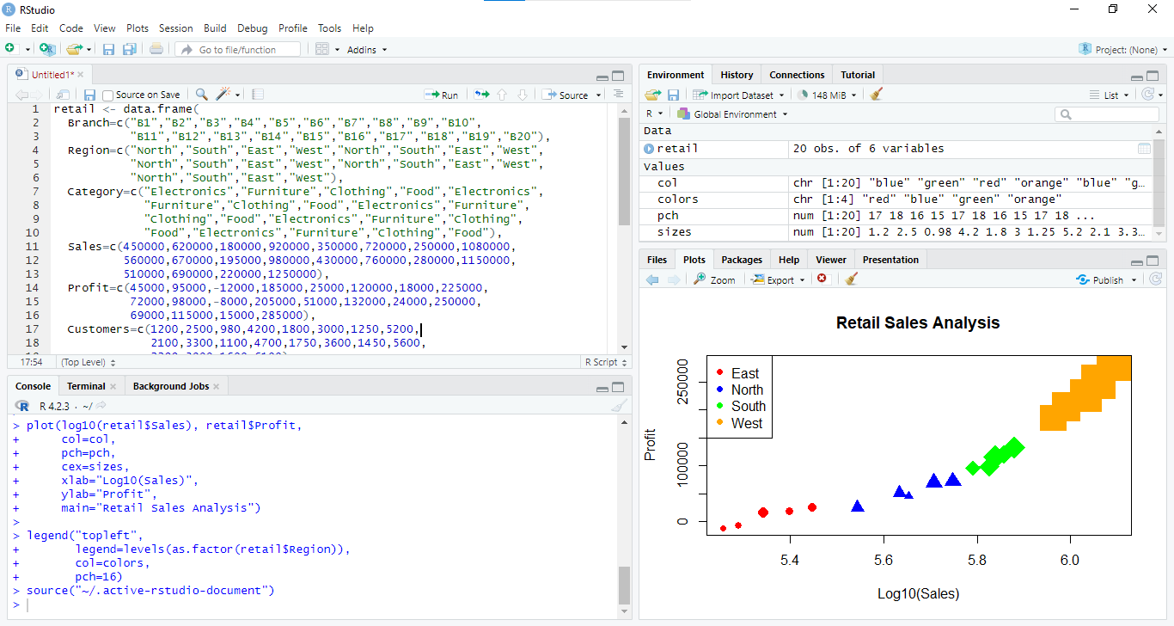
Explanation
- A scatter plot is used to visualize the relationship between Sales and Profit.
- The log10 transformation is applied to Sales to reduce skewness and improve readability.
- Different colors represent different Regions.
- Different symbols (pch) represent Product Categories.
- Bubble size (cex) represents the number of Customers.
- The legend helps identify the region represented by each color.

Question 2: Electricity Generation Visualization
R Code
energy <- data.frame(
Month=month.abb,
Coal=c(620,580,590,605,640,670,690,720,700,680,650,630),
Gas=c(310,295,305,320,340,355,360,370,365,350,335,320),
Solar=c(45,60,90,130,180,230,250,245,210,160,90,50),
Wind=c(80,95,120,150,170,185,195,190,175,150,110,90),
Hydro=c(140,150,160,170,180,195,205,210,200,185,165,150)
)

matplot(1:12,
energy[,2:6],
type="l",
lty=1,
lwd=2,
col=1:5,
xaxt="n",
xlab="Month",
ylab="Generation",
main="Monthly Electricity Generation")

axis(1,1:12,energy$Month)

legend("topleft",
legend=names(energy)[2:6],
col=1:5,
lty=1)

pie(colSums(energy[,2:6]),
labels=names(energy)[2:6],
main="Electricity Generation by Source")

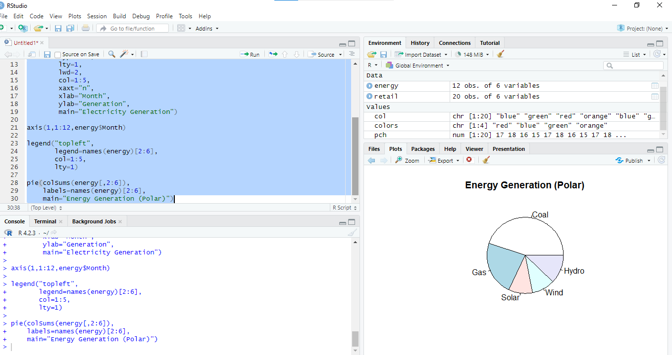

Explanation
- Line chart (Cartesian coordinate) displays monthly trends for each energy source.
- Pie chart (Polar coordinate) represents the contribution of each energy source.
- The Cartesian graph is better for analyzing trends over time.
- The Polar graph is useful for showing the proportion of total energy generation.

Question 3: Climate Data Visualization

R Code
climate <- data.frame(
City=c("Delhi","Mumbai","Chennai","Kolkata","Hyderabad",
"Bangalore","Pune","Ahmedabad","Jaipur","Lucknow",
"Bhopal","Patna","Goa","Kochi","Nagpur","Indore",
"Surat","Visakhapatnam","Coimbatore","Mysuru"),
Temperature=c(44,35,38,40,39,31,33,43,45,39,
38,40,32,30,41,37,36,34,29,28),
Humidity=c(22,84,78,72,48,66,58,26,18,42,
36,45,89,91,30,34,76,82,68,64),
Rainfall=c(6,280,220,190,85,120,95,2,1,35,
48,72,360,410,12,20,180,240,130,145),
AQI=c(365,110,125,180,160,72,84,290,320,240,
175,220,58,52,270,190,145,98,60,55)
)

cols <- heat.colors(20)[rank(climate$Humidity)]

plot(climate$Temperature,
climate$AQI,
cex=climate$Rainfall/60,
col=cols,
pch=19,
xlab="Temperature",
ylab="AQI",
main="Climate Analysis")

text(climate$Temperature,
climate$AQI,
labels=climate$City,
pos=3,
cex=0.6)

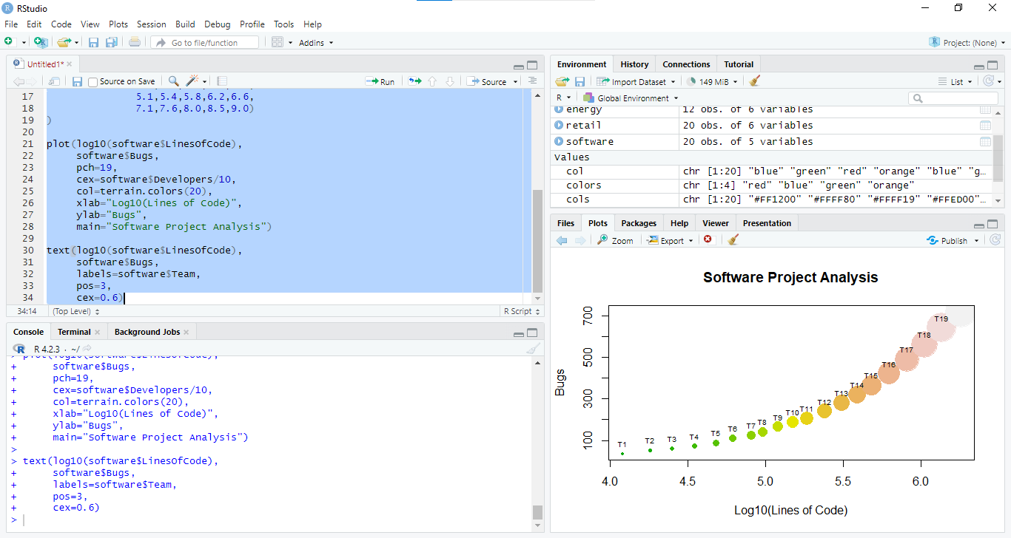

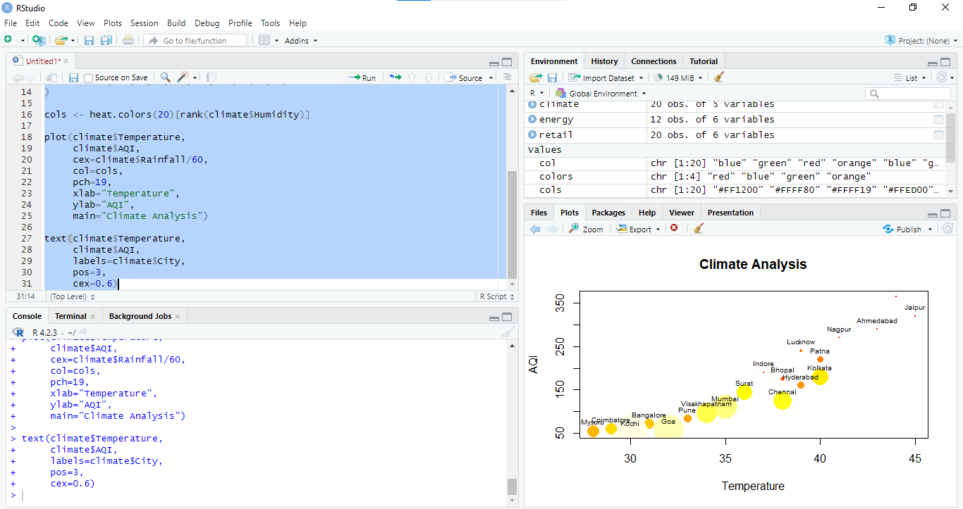

Explanation
- Scatter plot shows the relationship between Temperature and AQI.
- Color represents Humidity.
- Bubble size represents Rainfall.
- City names are displayed using the text() function.
- The heat color palette provides an easy way to distinguish humidity levels.

Question 4: Software Project Statistics

R Code
software <- data.frame(
Team=paste("T",1:20,sep=""),
LinesOfCode=c(12000,18000,25000,35000,48000,
62000,81000,96000,120000,150000,
185000,240000,310000,390000,480000,
620000,810000,1050000,1350000,1800000),
Bugs=c(35,52,60,72,88,
110,125,142,165,188,
205,240,280,320,365,
420,490,560,640,720),
Developers=c(5,7,9,10,12,
14,16,18,20,22,
25,28,30,34,38,
42,46,50,55,60),
Complexity=c(2.1,2.4,2.7,3.0,3.2,
3.5,3.8,4.1,4.5,4.8,
5.1,5.4,5.8,6.2,6.6,
7.1,7.6,8.0,8.5,9.0)
)

plot(log10(software$LinesOfCode),
software$Bugs,
pch=19,
cex=software$Developers/10,
col=terrain.colors(20),
xlab="Log10(Lines of Code)",
ylab="Bugs",
main="Software Project Analysis")

text(log10(software$LinesOfCode),
software$Bugs,
labels=software$Team,
pos=3,
cex=0.6)

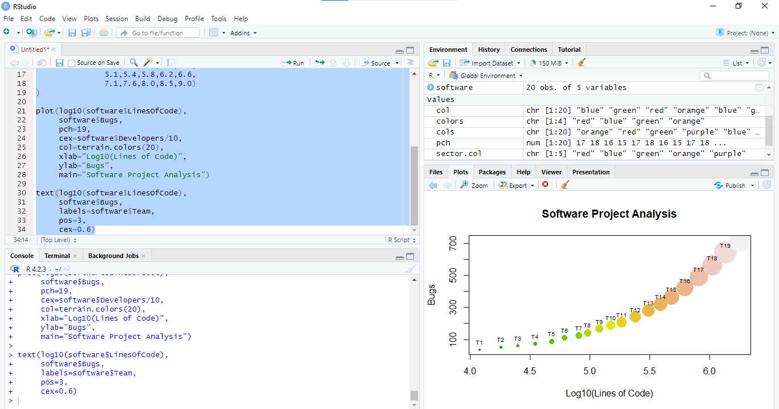

Explanation
- A scatter plot is used to analyze the relationship between Lines of Code and Bugs.
- A logarithmic transformation is applied to Lines of Code because the values are highly skewed.
- Bubble size represents the number of Developers.
- Different colors indicate variation among teams.
- Team names are displayed above each point.

Question 5: Company Performance Visualization

R Code
companies <- data.frame(
Company=paste("C",1:20,sep=""),
Sector=c("IT","Banking","Healthcare","Retail","Energy",
"IT","Banking","Healthcare","Retail","Energy",
"IT","Banking","Healthcare","Retail","Energy",
"IT","Banking","Healthcare","Retail","Energy"),
Revenue=c(420,580,720,850,980,
1150,1320,1480,1650,1820,
2050,2280,2550,2840,3150,
3480,3860,4250,4680,5200),
ProfitMargin=c(8.2,15.6,11.4,9.3,18.5,
20.4,17.8,14.2,10.5,22.1,
24.5,19.8,16.7,13.4,26.2,
28.1,21.5,18.3,15.2,30.4),
Employees=c(1500,3200,2100,4200,2800,
5100,6800,3900,7200,4500,
8100,9500,6200,10300,7200,
11800,13200,8600,14500,16000),
MarketCap=c(8500,12000,9800,7600,14500,
18200,21500,16800,13200,24500,
28500,32500,24800,19200,38200,
42500,46800,35600,29800,52000)
)

sector.col <- c("red","blue","green","orange","purple")
cols <- sector.col[as.numeric(as.factor(companies$Sector))]

plot(companies$Revenue,
companies$ProfitMargin,
cex=companies$MarketCap/8000,
col=cols,
pch=19,
xlab="Revenue",
ylab="Profit Margin",
main="Company Performance")

legend("topleft",
legend=levels(as.factor(companies$Sector)),
col=sector.col,
pch=19)

text(companies$Revenue,
companies$ProfitMargin,
labels=companies$Company,
pos=3,
cex=0.7)
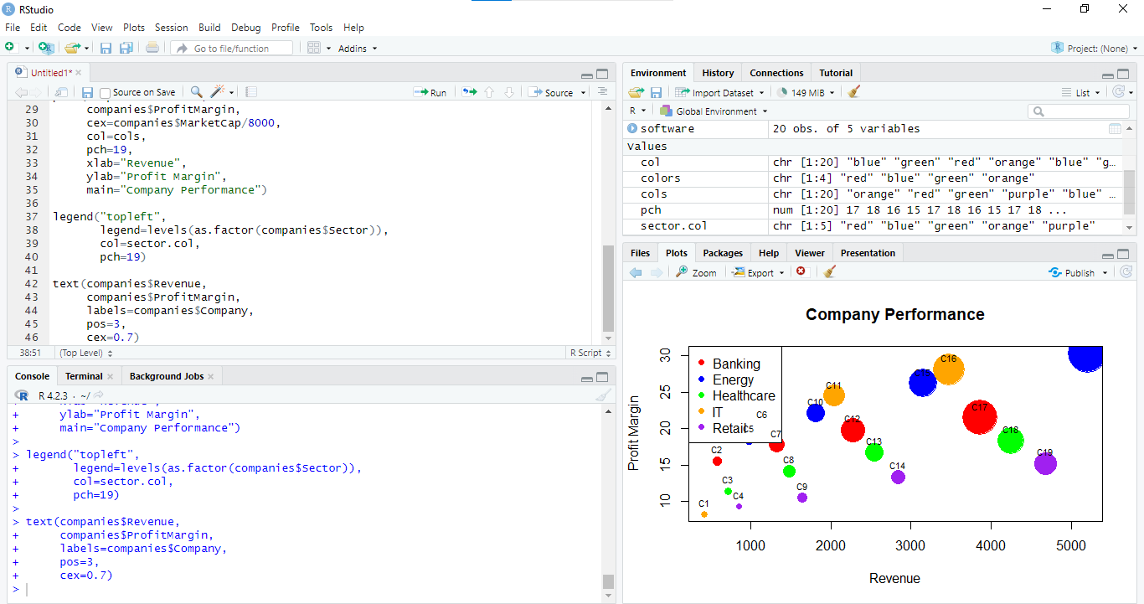
Explanation
- A scatter plot is used to compare Revenue and Profit Margin.
- Different colors distinguish Industry Sectors.
- Bubble size represents Market Capitalization.
- Company names are displayed beside each point.
- A legend is included to identify sector colors.
- This visualization effectively represents multiple variables while maintaining readability.

